Step1: Create a directory Jenkins-demo
mkdir jenkins-demo
cd jenkins-demo
Step2: Initialize git
git init
Step3: Create a simple script file hello.sh
hello.sh:
cat > hello.sh << 'EOF'
#!/bin/bash
echo "Build triggered at: $(date)"
echo "Running on host: $(hostname)"
echo "Branch: $GIT_BRANCH"
echo "Commit: $GIT_COMMIT"
EOF
chmod +x hello.sh
Step4: Push the file to github
git add .
git commit -m "Initial commit: add hello.sh"
git branch -M main
git remote add origin https://github.com/antben/jenkinstask2.git
git push -u origin main
Step5: Install Jenkins
curl -fsSL https://pkg.jenkins.io/debian-stable/jenkins.io-2023.key | \ sudo gpg --dearmor -o /usr/share/keyrings/jenkins-keyring.gpg
# Add the repo pointing to the new keyring file
echo "deb [signed-by=/usr/share/keyrings/jenkins-keyring.gpg] \ https://pkg.jenkins.io/debian-stable binary/" | \ sudo tee /etc/apt/sources.list.d/jenkins.list > /dev/null
# Update and install
sudo apt update
sudo apt install jenkins -y
Start Jenkins:
sudo systemctl restart jenkins
sudo systemctl status Jenkins
jenkins –version
Step6: Login to Jenkins using password file
sudo cat /var/lib/jenkins/secrets/initialAdminPassword
URL: http://35.154.37.103:8080/
Step6: Install below plugins
Git plugin (likely already installed)
GitHub plugin
Mailer plugin (for email notifications)
Step7: Configure Email:
Manage Jenkins → System → E-mail Notification
SMTP server smtp.gmail.com
Use SSL✅ checked
SMTP Port465
User Name antonbeniles@gmail.com
Passwordyour Gmail App Password generated from myaccount.google.com/apppasswords
Reply-To Address antonbeniles@gmail.com
Step8: Add GitHub credentials to Jenkins
Manage Jenkins → Credentials → System → Global credentials → Add Credentials:
Kind: Username with password
Username: GitHub username
Password: GitHub Personal Access Token (not your GitHub password)
ID: github-creds
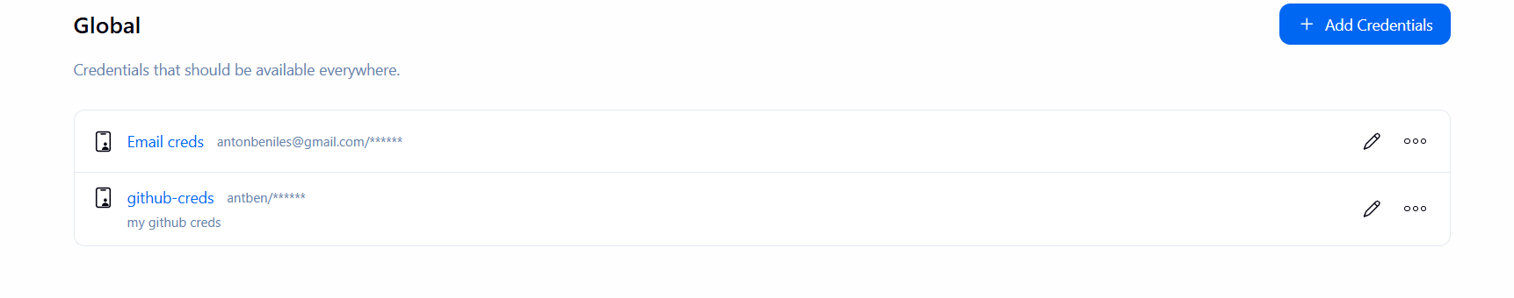
Step9: Create the Jenkins project
Dashboard → New Item → name it jenkins-demo → select Pipeline → OK
Configure options as seen in screenshot:
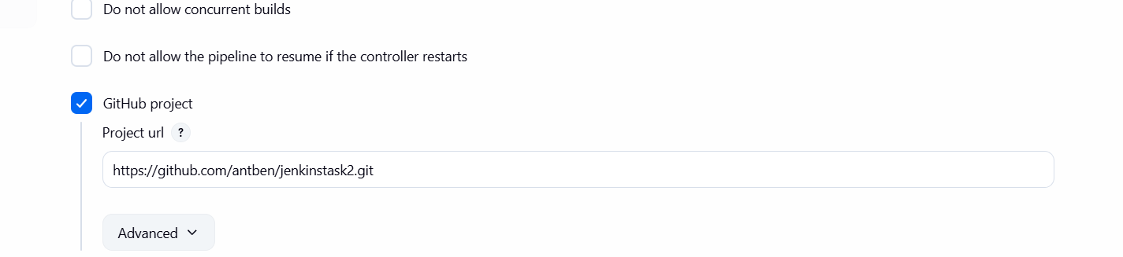
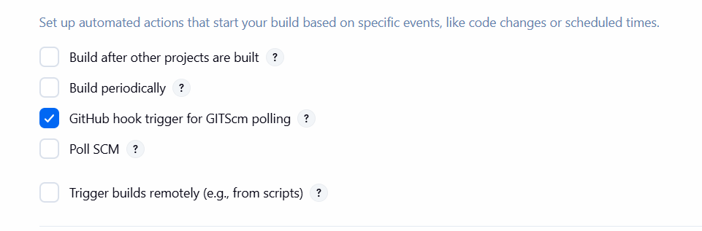
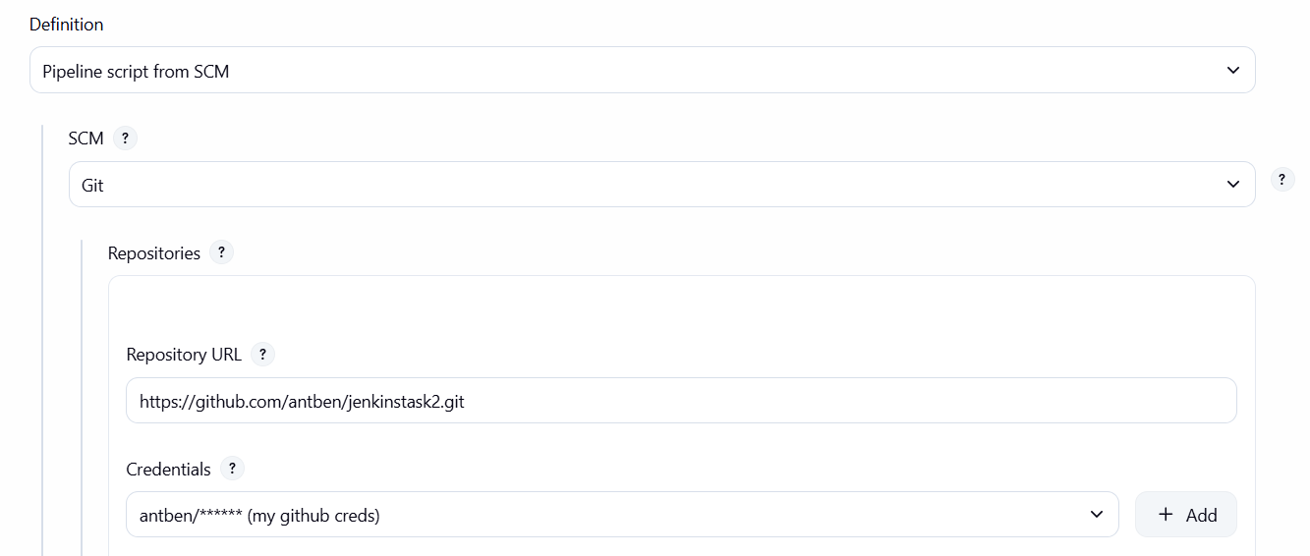
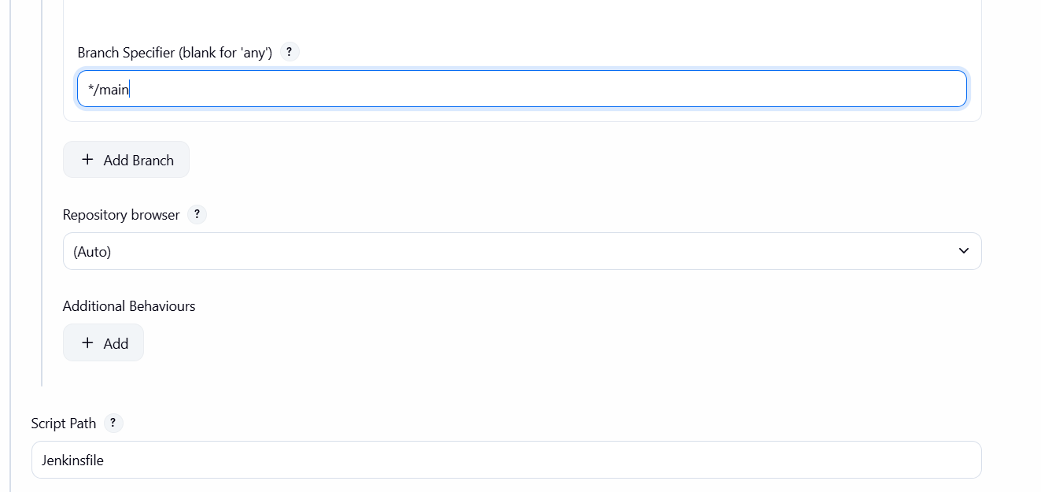
Step10:Configure webhook in Github
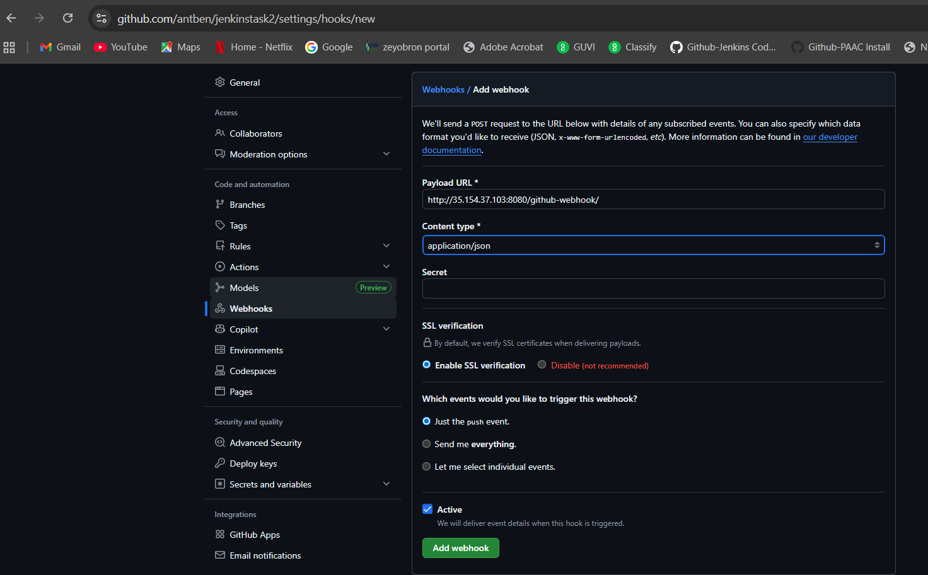
Step11: Create Jenkinsfile
pipeline {
agent any

stages {
stage('Checkout') {
steps {
echo 'Cloning repository...'
checkout scm
}
}

stage('Run Script') {
steps {
echo 'Running hello.sh...'
sh 'bash hello.sh'
}
}
}

post {
success {
echo 'Build succeeded!'
mail to: 'antonbeniles@gmail.com',
subject: "SUCCESS: Jenkins Build #${env.BUILD_NUMBER}",
body: """Build #${env.BUILD_NUMBER} completed successfully.

Job: ${env.JOB_NAME}
Build URL: ${env.BUILD_URL}

Console Output: ${env.BUILD_URL}console"""
}

failure {
echo 'Build failed!'
mail to: 'antonbeniles@gmail.com',
subject: "FAILED: Jenkins Build #${env.BUILD_NUMBER}",
body: """Build #${env.BUILD_NUMBER} failed.

Job: ${env.JOB_NAME}
Build URL: ${env.BUILD_URL}

Check console output: ${env.BUILD_URL}console"""
}
}
}
Step12: Push it to Github
git add Jenkinsfile
git commit -m "Add Jenkinsfile"
git push

This will trigger the build:
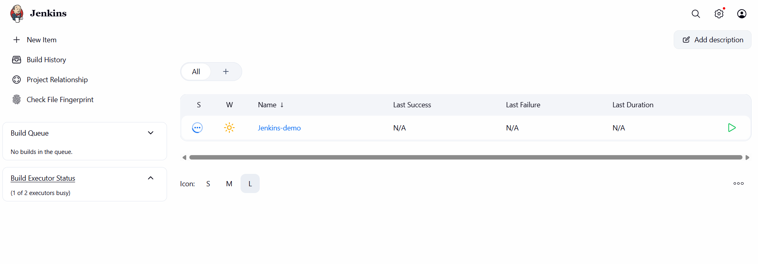

Console Output:
Started by GitHub push by antben
Obtained Jenkinsfile from git https://github.com/antben/jenkinstask2.git
[Pipeline] Start of Pipeline
[Pipeline] node
Running on Jenkins in /var/lib/jenkins/workspace/Jenkins-demo
[Pipeline] {
[Pipeline] stage
[Pipeline] { (Declarative: Checkout SCM)
[Pipeline] checkout
Selected Git installation does not exist. Using Default
The recommended git tool is: NONE
using credential github-creds
> git rev-parse --resolve-git-dir /var/lib/jenkins/workspace/Jenkins-demo/.git # timeout=10
Fetching changes from the remote Git repository
> git config remote.origin.url https://github.com/antben/jenkinstask2.git # timeout=10
Fetching upstream changes from https://github.com/antben/jenkinstask2.git
> git --version # timeout=10
> git --version # 'git version 2.53.0'
using GIT_ASKPASS to set credentials my github creds
> git fetch --tags --force --progress -- https://github.com/antben/jenkinstask2.git +refs/heads/*:refs/remotes/origin/* # timeout=10
> git rev-parse refs/remotes/origin/main^{commit} # timeout=10
Checking out Revision f9aab6ced1875cae86b86da07e6e8e97c3ff2011 (refs/remotes/origin/main)
> git config core.sparsecheckout # timeout=10
> git checkout -f f9aab6ced1875cae86b86da07e6e8e97c3ff2011 # timeout=10
Commit message: "Test email notification"
> git rev-list --no-walk 786021aef2b5b244d2b97ab0cd7c1bae6c57e749 # timeout=10
[Pipeline] }
[Pipeline] // stage
[Pipeline] withEnv
[Pipeline] {
[Pipeline] stage
[Pipeline] { (Checkout)
[Pipeline] echo
Cloning repository...
[Pipeline] checkout
Selected Git installation does not exist. Using Default
The recommended git tool is: NONE
using credential github-creds
> git rev-parse --resolve-git-dir /var/lib/jenkins/workspace/Jenkins-demo/.git # timeout=10
Fetching changes from the remote Git repository
> git config remote.origin.url https://github.com/antben/jenkinstask2.git # timeout=10
Fetching upstream changes from https://github.com/antben/jenkinstask2.git
> git --version # timeout=10
> git --version # 'git version 2.53.0'
using GIT_ASKPASS to set credentials my github creds
> git fetch --tags --force --progress -- https://github.com/antben/jenkinstask2.git +refs/heads/*:refs/remotes/origin/* # timeout=10
> git rev-parse refs/remotes/origin/main^{commit} # timeout=10
Checking out Revision f9aab6ced1875cae86b86da07e6e8e97c3ff2011 (refs/remotes/origin/main)
> git config core.sparsecheckout # timeout=10
> git checkout -f f9aab6ced1875cae86b86da07e6e8e97c3ff2011 # timeout=10
Commit message: "Test email notification"
[Pipeline] }
[Pipeline] // stage
[Pipeline] stage
[Pipeline] { (Run Script)
[Pipeline] echo
Running hello.sh...
[Pipeline] sh
+ bash hello.sh
[Pipeline] }
[Pipeline] // stage
[Pipeline] stage
[Pipeline] { (Declarative: Post Actions)
[Pipeline] echo
Build succeeded!
[Pipeline] mail
[Pipeline] }
[Pipeline] // stage
[Pipeline] }
[Pipeline] // withEnv
[Pipeline] }
[Pipeline] // node
[Pipeline] End of Pipeline
Finished: SUCCESS

